# **Module 0: Getting Started**

**Exercise 0: Checking the Exercise Equipment**

**Task 1: Ensure Connectivity to your ONTAP Cluster**

**Pg_8(step1-8):** The screenshot will vary so refer the below image.



**Task 2: Synchronous System Time for Windows Domains**

**Note**: The **Time Zone** of the **ONTAP Cluster** and the **Windows Domain** will be in **Asia/Singapore** so don’t change the **time or time zone** in this task.

# **Module 2: SnapMirror Fundamentals**

**Exercise 2: Configuring Cluster Peering and SVM Peering**

**Task 1: Create Intercluster LIFs**

**Pg_19(step_1-6):** The screenshot may vary for the **System Manager Dashboard**.

**Pg_21(step_1-11):** The screenshot will vary so kindly refer the below image

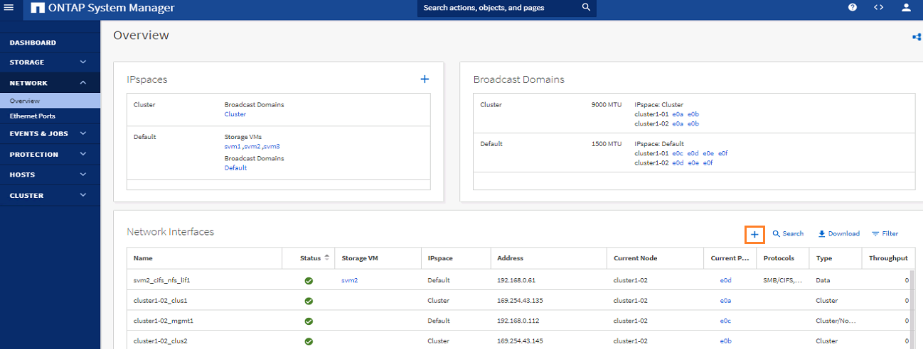

**Task 3: Configure Cluster Peering**

**Pg_30(step_3-13):** To check the **current health status** of cluster peer relationship use the below command

cluster1: :> cluster peer health show -bypass-cache true

# **Module 3: SnapMirror Operation**

**Exercise 1: Using SnapMirror Asynchronous to Mirror FlexVol Volumes**

**Task 2: Verify Data Transfer**

**Pg_44(step2-4):** In the **Export Settings section, Mount path** will be shown only after clicking the **Mount** checkbox**.** The screenshot will vary.

**Pg_47(step2-15):** In the **Map Network Drive** window, the **Reconnect at sign-in** checkbox will be in **unchecked** stateso the screenshot will vary**.**

**The following output in the respective steps varies because of Reconnect at sign-in:**

* + - * Page48_Step 2-17
      * Page82_Step 2-3
      * Page 88_Step2-21
      * Page 106_Step3-13
      * Page 129_Step4-15

**Exercise 3: Configuring SnapMirror Unified Replication for Vaulting**

**Task 2: Verify Data Transfer**

**Pg_86(step2-14):** In the **Export Settings section, Mount path** will be shown only after clicking the **Mount** checkbox**.** The screenshot will vary.

**Exercise 5: Configuring a SnapMirror Synchronous Relationship**

**Task 1: Create an SM-S Policy**

**Pg_94(step_1-5):** After selecting the **Policy Type** check that the **Policy Name** is applied properly**.**

**Task 2: Create an SM-S Relationship**

**Pg_97(step2-9):** It takes few minutes for the **smb2_share_CIFS_volume** changes to **In sync** in the **Status**.

# **Module 4: SVM DR**

**Exercise 1: Configure SVM**

**Task 1: Check Space Requirements**

**Pg_113(step_1-1):** The screenshot will vary for the **Volume page**, so refer the below image.

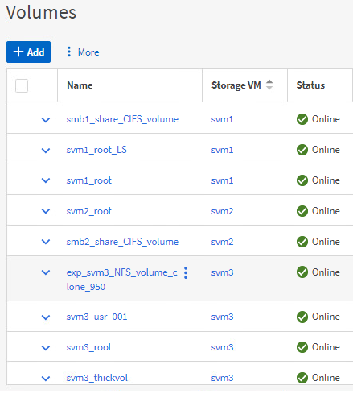

**Pg_114(step_1-4):** In the **Capacity Column**, position your cursor over the blue color in the capacity bar to view the **used capacity**.

**Pg_115(step_1-8):** Navigate to **Tier > HDD** pane, the screenshot will vary for the **Tier > HDD** pane, so refer the below image.

**Task 3: Create SVM DR Relationship**

**Pg_121(Step_3-7):** In the Relationship page, the State of the relationship will reflect Mirrored once the transfer status turns to idle.

**Pg_123(Step_3-11):** In the Settings page of svm3_dr, the screenshot will vary so kindly refer the below image.

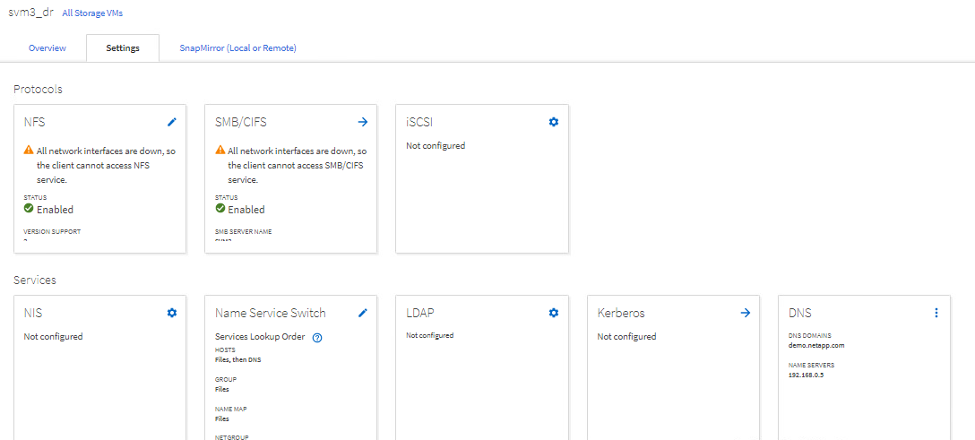

**Task 4: Fail Over to the Disaster-Recovery SVM**

**Pg_129(step4-15):** In the **Map Network Drive** window, the drive letter for mapping the CIFS share differs so the screenshot will vary**.**